In a given grid, each cell can have one of three values:

* the value 0 representing an empty cell;
* the value 1 representing a fresh orange;
* the value 2 representing a rotten orange.

Every minute, any fresh orange that is adjacent (4-directionally) to a rotten orange becomes rotten.

Return the minimum number of minutes that must elapse until no cell has a fresh orange.  If this is impossible, return -1 instead.

**Example 1:**

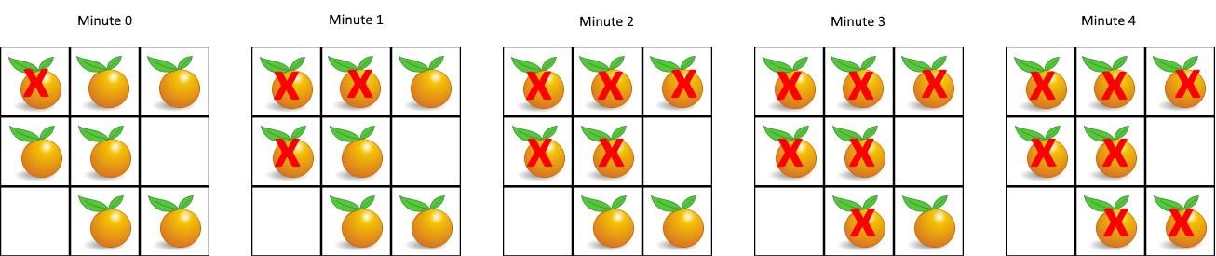

**Input:** [[2,1,1],[1,1,0],[0,1,1]]

**Output:** 4

**Example 2:**

**Input:** [[2,1,1],[0,1,1],[1,0,1]]

**Output:** -1

**Explanation:**  The orange in the bottom left corner (row 2, column 0) is never rotten, because rotting only happens 4-directionally.

**Example 3:**

**Input:** [[0,2]]

**Output:** 0

**Explanation:**  Since there are already no fresh oranges at minute 0, the answer is just 0.

**Note:**

1. 1 <= grid.length <= 10
2. 1 <= grid[0].length <= 10
3. grid[i][j] is only 0, 1, or 2.